User Manual

1. main entrance: run sortUI.py

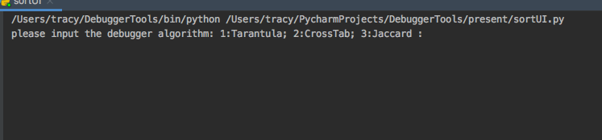

1. choose debugger algorithm: eg, input 1
2. input the program want to debug in testcase/suite : eg, insert_sort_1.py

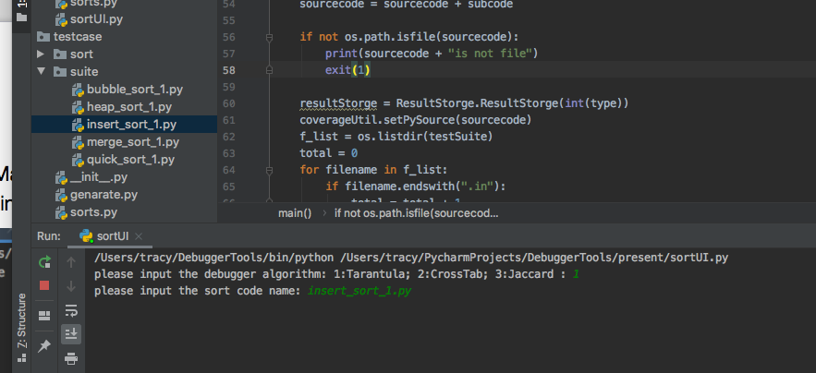

1. Get the suspiciousness rank of each statement:

